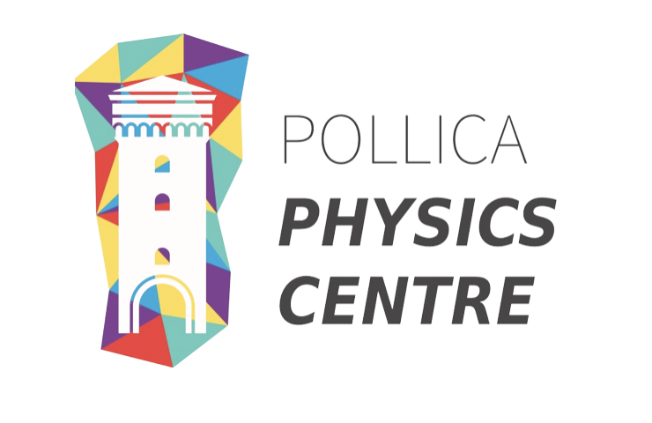

**Workshop application**

**(max 4 pages total)**

1. *Title and brief abstract of the workshop (1-2 paragraphs)*
2. *Relevant subfields and keywords*
3. *Organizers, their scientific affiliation and their email contact*
4. *Length of the workshop and preferred dates (please let us know of any time conflicts or possible overlap with other events)*

We are in the process of setting up a common visitor program with the Galileo Galilei Institute in Florence. Please mention any potential overlap with one of their workshops - see GGI program at <https://www.ggi.infn.it/workshops.html>

1. *Additional funding sources (please highlight source of funding that are guaranteed, and those who are pending)*
2. *Proposed speakers*
3. *Scientific outline (relevance of the work in the proposed area, state of the art of the topic, timeliness, choice of speakers and diversity of the speakers and organizing committee)* ***max 1 page***